Chief’s Neighborhood Liaison

Detroit Public Safety Headquarters

1301 Third Avenue, Suite 7-S

Detroit, MI 48226

Office (313) 596-2520

Fax (313) 596-1450

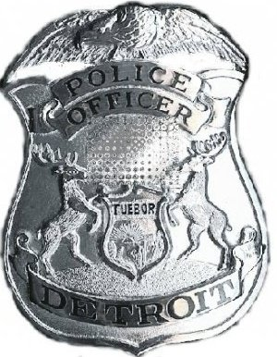

APPLICATION FOR CITIZENS RADIO PATROL

**(Confidential)**

**PLEASE PRINT**

**Name:______________________________________________________________**

**Date of Birth:_____________________Sex______Race_______________________**

**Address: ___________________________________________________________**

## City:_____________________________State:_________Zip Code:_____________

**Home: ( )______________Cell: ( )_____________ Business: ( )___________**

**Driver’s License Number:_______________________________________________**

Email Address:________________________________________________________   
Emergency Contact Person:______________________________________________

**Emergency Contact Telephone: ( )_____________________________________**

# How often can you serve on patrol (days/hours):______________________________

Name of Radio Patrol you plan to join (or Neighborhood):___BOSTON-EDISON____

Name of Radio Patrol President______TREVOR FOOTITT______________________

Signature of Applicant____________________________________Date____________________

*NOTICE: Incomplete applications will NOT be accepted. Please be certain to provide all requested information and email this information to:

DETROIT POLICE DEPARTMENT E-Mail to: Trevor Footitt

CHIEF’S NEIGHBORHOOD LIAISON trevnvic@sbcglobal.net

1301 THIRD AVENUE, SUITE 7-SOUTH 2205 Longfellow

DETROIT, MI 48226 Detroit MI 48206

Privacy Act Notice: The Detroit Police Department’s application form for the Citizen’s Radio Patrol requests your Driver’s License Number. The request is made pursuant to the Department’s practice of requiring program participants to undergo a criminal history record check and using the Driver’s License Number along with any identifying information to conduct criminal history record checks on them. This information is necessary for the Detroit Police Department to obtain accurate criminal history information and will be used solely for that purpose. Signing this document indicates that you have read and understand that your Driver’s License Number will be used by the Detroit Police Department to obtain access to your criminal history information.