Historic Boston Edison Association
Voigt Park Recommendations

Introduction :
The Historic Boston-Edison Association (HBEA) began its journey to develop recommendations for Voigt Park uplifting be better used by neighbors. This has been a two year and eight months process to ensure that all voices were heard within the Historic Boston Edison District.

Under the Beautification Committee of the Association, a Parks Subcommittee was created to provide recommendations for maintenance and improvements to Voigt Park. The committee consists of nine (9) members from various zones within the Boston-Edison District. These recommendations are informed by a neighborhood survey that was completed regarding current concerns and desired improvements to our neighborhood city parks.

Summary :
The Historic Boston Edison Association recommends the following elements for Voigt Park: the planting and maintenance of additional trees, creation of formal and native flower beds, to re-create some of the historic network of pathways, and the addition of four (4) park benches along the pathways for seating. Trash bins at strategic sidewalk edge locations, and the relocation of doggie stations to coincide with the pathways, should also be included. Park Signage to be replaced and located at two key intersections on both sides of the park.

Background :
Voigt Park provides a historic significance within the Boston-Edison neighborhood and is a frequent spot of neighborhood use and engagement. The City of Detroit has a landscape plan of Voigt Park from 1928 showing the original design of the park, which coincides with the historic period of the neighborhood development. The design of the park has several defining features. A significant number of large shade trees were planted in the early development of Voigt Park; these trees are now larger and add to the natural features of the park. A network of pathways beginning at each of the four street intersections, wind through the block, and meet at a central plaza. The network of walkways had a formal organization, with two large circular flower beds symmetrically positioned.

Objectives :
To improve maintenance and accessibility of Voigt Park, so the park can be used and enjoyed by neighbors, residents of the City of Detroit and other visitors. The recommendations take into consideration the historic character of the district, while meeting the current and future needs of our neighborhood. To provide a framework that meets the needs of the community, based on the neighborhood survey, and can be maintained by City Parks and Recreation as part of the park network. HBEA looks forward to further development and engagement with the City Parks department to further define specific technical issues, design, and materials, as part of a final proposal.

Scope :
The scope of maintenance and recommendations to Voigt Park are outlined below.

- The initial step to improving Voigt Park should be to address the current standing water and drainage issues that occur in multiple locations throughout the park. These areas should be mitigated prior to planning and locating new features, to ensure their longevity and success. The expertise of landscape professionals is needed to evaluate the situation. Possible considerations for mitigation may include: the addition of a catch basin to tie into the existing storm water sewer line running through the park, and/or green infrastructure methods, like a rain garden or similar.

- Establish a long-term plan of existing tree maintenance in addition to the planting of new trees. This will maintain the quality and variety of old and new growth trees and species within the park.
- Establish a maintenance plan for the approximately thirty (~30) remaining original trees. Removal of the nine (9) dead or unhealthy trees. This information is based on the most recent study and review of the trees by the city's arborist .
- New trees should be added to maintain the diversity of old growth and new growth plantings. New trees to be planted as close to the locations of the original trees as is possible without damaging existing trees and considering site conditions, sun exposure, and soil characteristics. Final determinations to be established by Detroit Parks and Recreation.
- New trees to have varieties that match the form and character of the historic landscape plan; primarily large canopy hardwood tree varieties, specific species to be selected by Detroit Parks and Recreation. The committee prefers the planting of native tree species whenever possible.
- New trees to have a wider variety of species than noted in the historic landscape plan to diversify the park ecosystem for a sustainable and healthy landscape, as well as to make the park more educationally interesting.
- Unique tree species to be replaced, according to the historic landscape plan: including large spruce trees in the center of the park and three flowering trees or similar at the east end of the park.
- Non-historic trees should not be removed, if they are healthy: non-historic trees that do not have the form and character of the original trees still augment the surviving landscape design and can be replaced when they eventually reach the end of their lifespan.
- Priority in replanting new trees as close as possible to historic locations, on the perimeter areas of the park where most of the historic trees have been lost.
- The committee recommends preserving the open spaces as indicated on the historic 1928 landscape plan.
- Consideration of flood-prone areas of the park and impact on planting plan; identify species that can tolerate inundation and will assist with water uptake in these locations.
3. Provide accessible Pathways through the landscape.
  - Re-create the pathway network of the historic 1928 landscape plan, omitting the central axial pathway connecting Longfellow + Edison Avenues.
  - Pathway Material recommendations: natural, pervious, low maintenance and accessible.
    - Preferred inclusion of an edge condition for maintenance and longevity of the pathway material.
    - Pathway material to be reasonably maintained by City Parks and Recreation staff over the life of the park.
  - Create a circular plaza similar in size and diameter to the historic 1928 landscape plan. The plaza will provide space for multiple uses and functions.
    - Definition of this plaza area to be a different or contrasting material to the pathway surface. Preference for the plaza material is a pervious surface, softer than concrete, that allows for the ability to put up tents and other elements for events. This surface should be flush with the path height or grade to avoid trip hazards and changes in grade.
    - Provide a potable water connection and electrical box for the ability to host a variety of events in this location.

4. Establish Flower beds and native planting beds.
- The two (2) flowering beds in the pathway circles on the East and West sides of the park to be formal flower planting beds. Providing seasonal color and a mixture of annual and perennial plants, to be determined by the Parks department. These beds should be defined with a raised curb or edge approximately 6” - 8” tall. The material of this curb or edge should be complementary to the pathway material, and the overall look and feel of the park.
- Locate low profile planting beds as close to the historic locations (labeled as shrub beds or specimen shrubs in the 1928 landscape plan), as possible giving consideration to existing trees and pathway locations. The planting beds should have mulched edges with a variety of native plants / species to be determined by the Parks department.
- Additional planting beds to be preserved or restored at the two (2) proposed sign locations with a mixture of flowering and native plants to be determined by the Parks department. These planting beds should have similar qualities to the historic planting bed locations.
- The committee recommends preserving the open spaces as indicated on the historic 1928 landscape plan. Any additional planting beds necessary to improve drainage within the park, should be offset by the deduction of an historic planting bed, to maintain the unplanted / grassy areas.
- Consider the type and quality of plants within the existing planting bed on the corner of Third and Edison, for consistency with the look and feel of the rest of the park; to be maintained or removed at the discretion of the Parks department.
- All flower and planting beds to be maintained by the City over the life of the park.

5. Provide opportunities for seating and enjoyment of the park.
- All proposed and future seating locations within the park to be located within well-lit areas, as provided by the existing lights.
- Provide four (4) benches, one along each of the pathways leading to the central East-West axis. Benches to be 6’-0” wide with a back and horizontal strapping in black with no center arm. A design in line with the Scarborough Bench by Landscape Forms, or similar. Refer to the updated Voigt Park plan for locations.
- Additional seating locations to be revisited by the City with HBEA input one year after the installation of the initial bench locations. Future bench locations to be determined by park use.
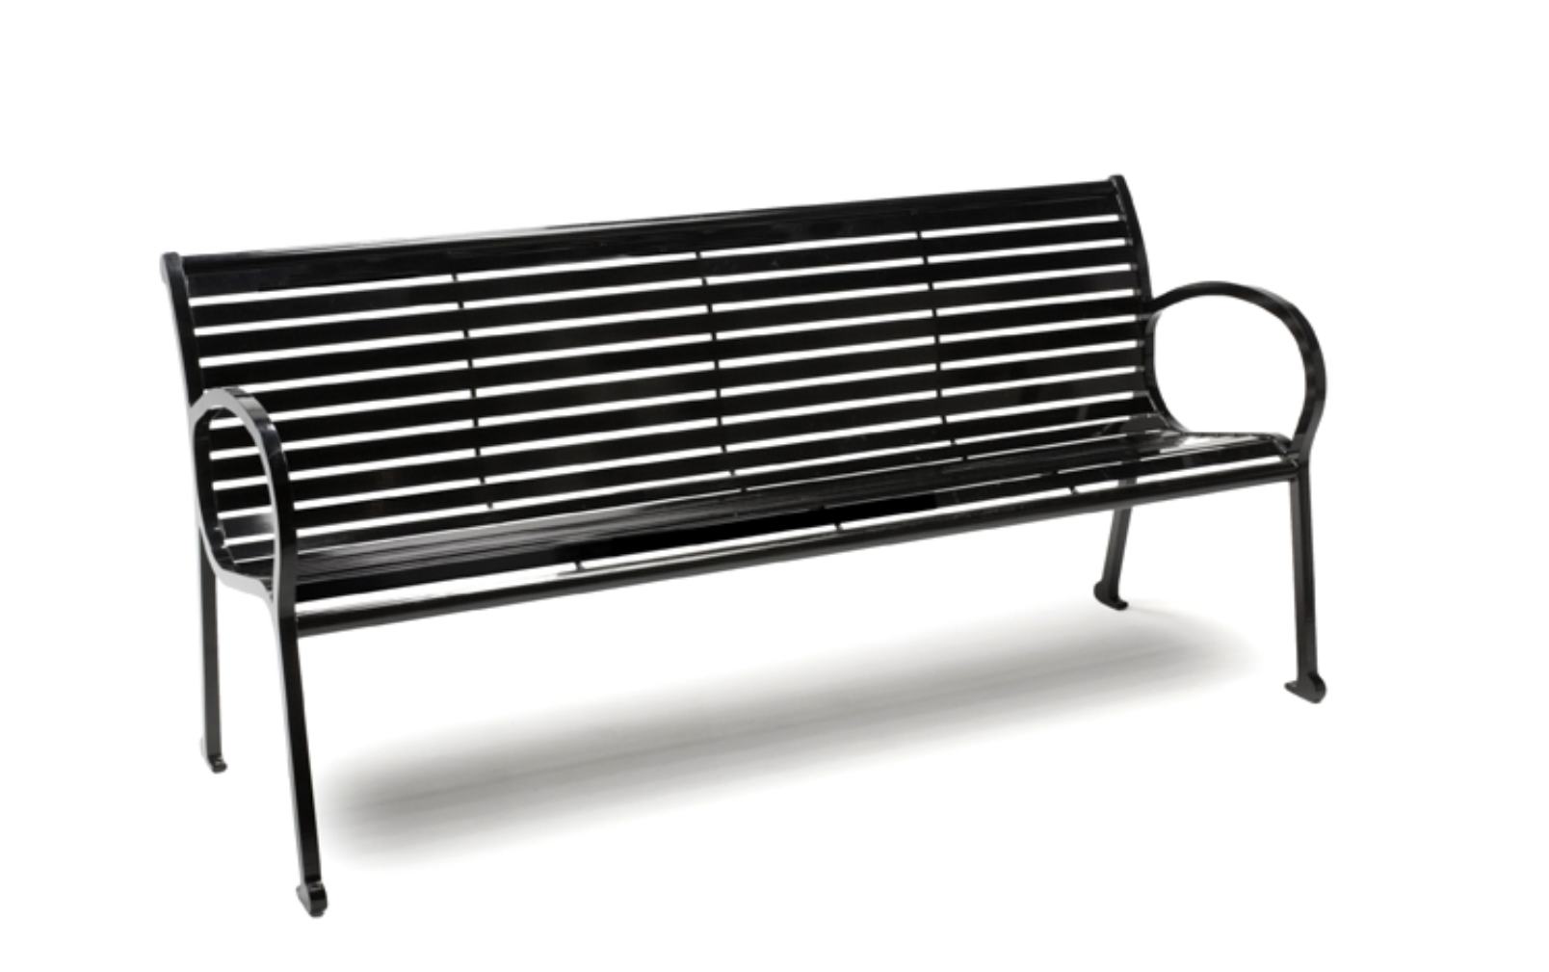

6. Provide trash and litter receptacles at strategic locations within the park that create a design consistency, and ease of access.
- Trash and litter receptacles to be easily accessible by city parks maintenance personnel.
- Locate a waste receptacle at each of the sidewalk intersections of the park, four (4) in total. Design to be Scarborough Litter side opening in black by Landscape Forms or of similar design. Trash bins should be secured to the ground to avoid tip-over.
- Relocate the existing two (2) doggie way-stations (in collaboration with HBEA) to convenient spots along the center pathways for ease of access and visibility.

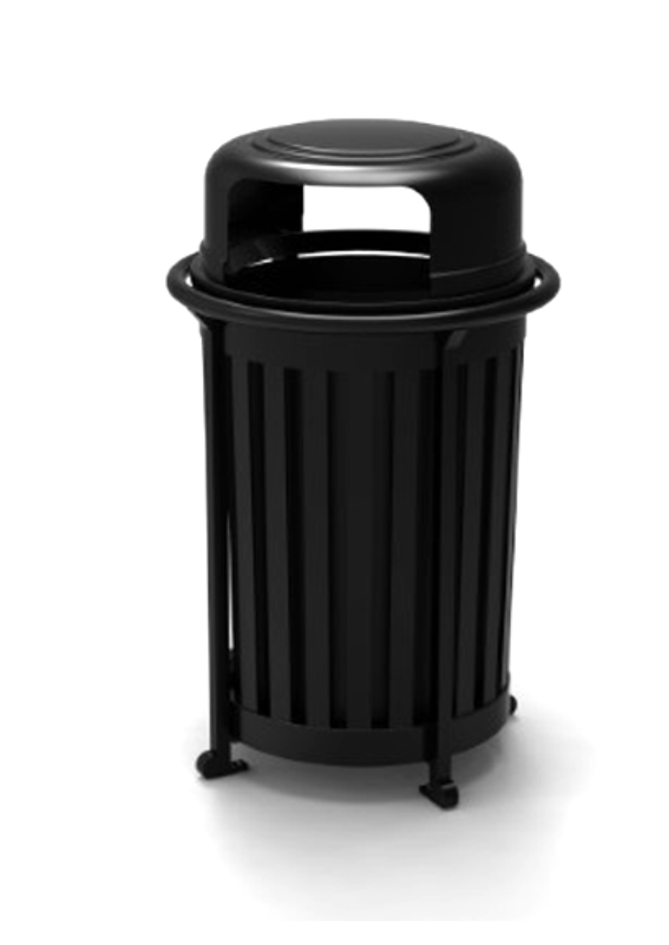

7. Replace and relocate Signage to provide better visibility.
- Provide two new signs to be located at the NW intersection of Longfellow + Third and the SE corner of Edison + Second, near current locations.
- Locate signs to work with proposed 1928 pathway locations, and proposed flowerbeds.
  - Relocate park rules to entry sign location(s) and install new Wayne County donation signage at these locations.

8. Explore other elements and improvements annually.

Fundraising:
The Historic Boston-Edison Association is prepared to contribute to the improvement of the Park to the best of its ability through its own fundraising efforts. It will work with the City of Detroit to coordinate its fundraising efforts for specific elements in the Park.

Included supplemental documents:
01/ Historic 1928 landscape plan
02/ Update Voigt Park Plan based on recommendations contained in this document

HBEA Board of Directors

