Historic Boston-Edison Association Parks Survey

The intent of this survey is to receive input from all neighbors regarding maintenance, amenities and potential programs in the park spaces that serve Historic Boston-Edison Association (HBEA) residents. HBEA and the Beautification committee will use this information to identify shared interests and priorities, and develop a strategy for maintenance and improvements within the parks.

Name: _____________________________________ Address: _____________________________________

Part I: Maintenance
- Are there particular parks and greenspaces in the neighborhood that you see trash and litter?
- No
- Yes, please describe location(s): ________________________________________________________
2. Are there particular parks and greensapces in the neighborhood where flower beds and trees need additional maintenance?
- No
- Yes, please describe location(s): ________________________________________________________

Part II: Gateway Parks
The gateway parks are located at Chicago Boulevard + Woodward Avenue, and consist of two parcels of land - Chicago Park to the North and Maiullo Park to the South.
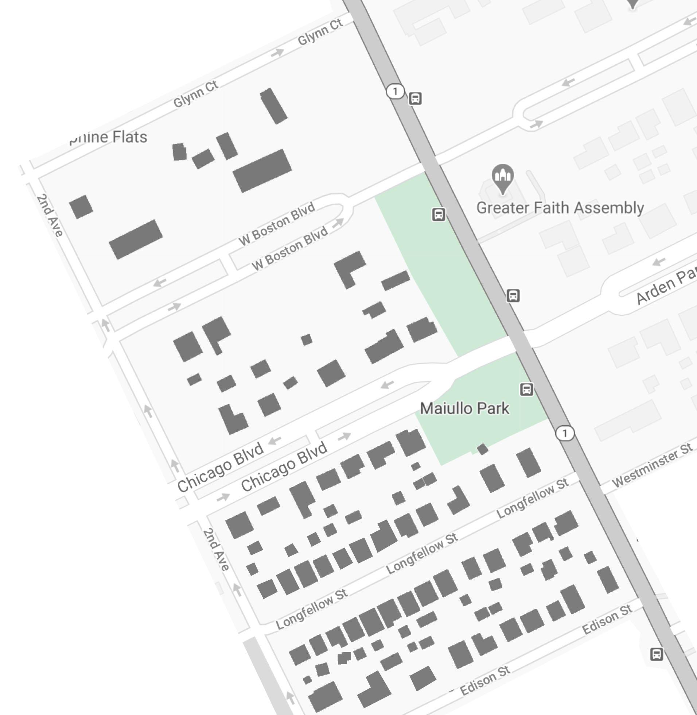
- How often do you walk-by, visit or utilize the Gateway Parks?
- Frequently
- Sometimes
- Rarely
- Never
- What are your current concerns for the Gateway Parks?
- Maintenance
- Security
- Trash / Litter
- I wasn’t aware these were public spaces
- Other

In 2010 HBEA commissioned a design proposal for the gateway parks. The proposal includes shrubs and additional trees, seasonal elements, pathways and signage:

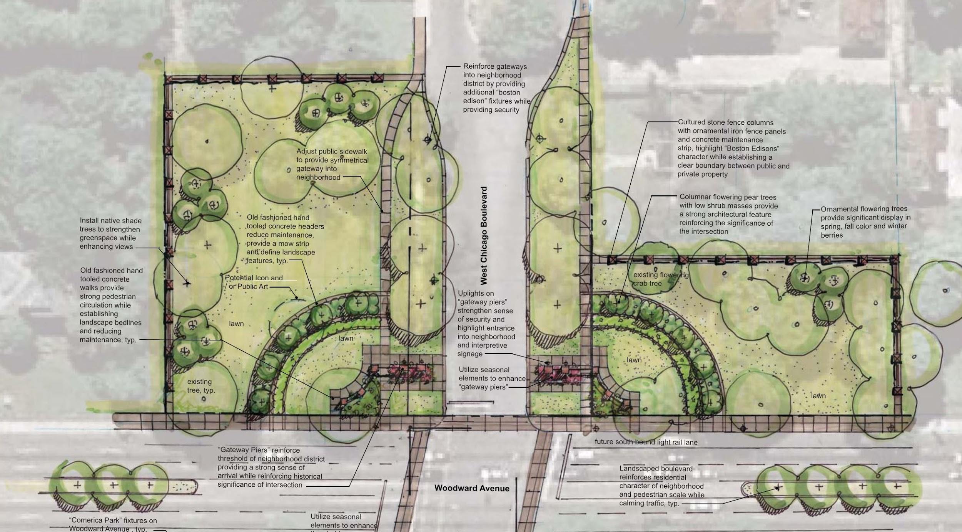

- What three elements in the design proposal would you like to see prioritized? (Select up to 3).
- Seasonal elements (flowers + shrubs)
- Shrubs
- Trees
- Signage
- Path / Sidewalk
- Edge boundary between public + private space

- How can the Gateway Parks be best utilized and enjoyed by all neighbors?

_________________________________________________________________________________________
_________________________________________________________________________________________
_________________________________________________________________________________________
Part III: Voigt Park
Voigt Park was established in the early 1900s, located between Second and Third Avenues and between Longfellow and Edison. In 2019 HBEA and the Beautification committee formed an ad-hoc committee to explore possible improvements for Voigt Park. The committee recommendation was to address drainage issues, address tree health and maintenance and to restore the walking path similar to the landscape plan from 1928.
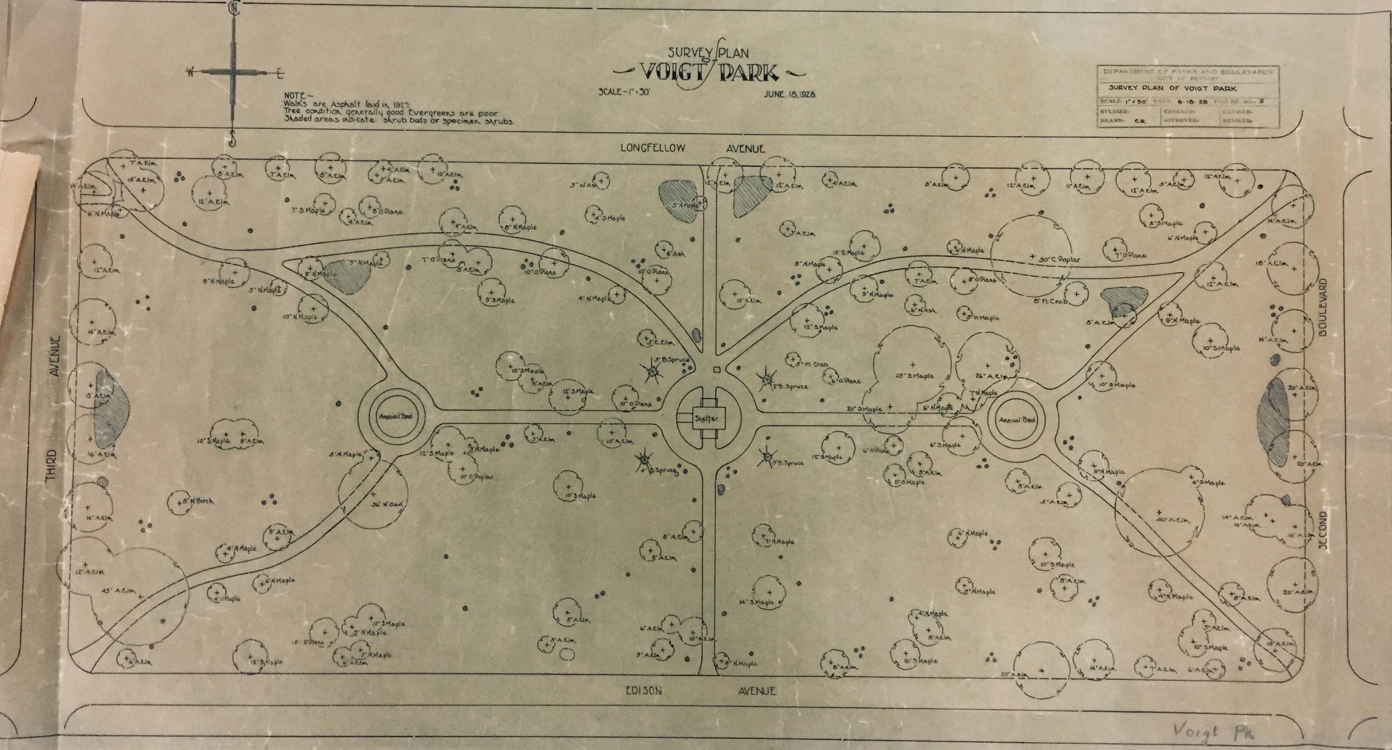
- How often do you walk-by, visit or utilize Voigt Park?
- Frequently
- Sometimes
- Rarely
- Never

- What are your current concerns for Voigt Park? (Select up to 3).
- Tree health and maintenance
- Standing water / Drainage
- Trash / Litter
- Maintaining historic character of the park
- None
- Other

- What features do you like most about Voigt Park?
________________________________________________________________________________________
________________________________________________________________________________________

- What are your priorities for additional amenities at Voigt Park? (Select up to 3)
- Flower beds
- Planting of additional trees
- Native plants
- Rain Garden
- Walking Path
- Benches
- Garbage / Recycle bins
- Other
- None - I like the park as it is.

- How can Voigt Park be best utilized and enjoyed by all neighbors?

_________________________________________________________________________________________
_________________________________________________________________________________________

Part IV: Neighborhood Engagement
The Boston-Edison neighborhood has multiple parks within walking distance, including the Gateway Parks, Voigt Park and Gordon Park.

- Which of the following community activities would you be interested in participating in (and at which park)? Note: Activities would take place abiding by state and local COVID-19 guidelines.
Community Activity | Gateway Parks | Voigt Park | Gordon Park
Yoga
Games
Pop-Up Movies
Music Concerts
Art Fairs or Art Installations
Children’s Storytime
Nature Walks
Birding
Tree Labels
Scavenger Hunts
Other (please list) | _______ | _______ | _______

